Post Mauryan Period, Shunga, Kanva, Chedi Dynasties
The Post Mauryan period is the period spanning from 200 BC to 300 AD after the disintegration of Mauryan Empire and continued foreign invasions.

By Vajiram Editor - Mar 2, 2026, 15:34 IST... Read more at: https://vajiramandravi.com/upsc-exam/post-mauryan-period/

The Post Mauryan Period between the fall of the Mauryas and the rise of the Guptas (2nd century BC to 3rd century AD), saw significant developments in the Indian subcontinent, which were characterised by changes in the subcontinent's political structure and the introduction of new elements in art, architecture, and religion.

The Mauryan Empire ruled over a large portion of the Indian subcontinent, including modern-day Afghanistan's Kandahar. The Mauryan Empire came to an end around 187 BC. The disintegration of the Mauryan empire resulted in the rise of numerous regional kingdoms and at the same time, various groups of people from Central Asia and western China invaded India which forms part of the Post Mauryan Period.

Political History during Post Mauryan Period
Following Asoka's death, his successors were unable to maintain the huge Mauryan Empire. The subsequent rulers were relatively weak and lacked the same level of administrative and military capabilities as their predecessors.

The provinces started declaring their independence.
The Mauryas lost control of northwest India, and the region was subjected to a series of foreign invasions.
Kalinga declared its independence, and the Satavahanas established their independent rule further south.
The religious policy of the Mauryas angered the Shungas, who were staunch followers of Brahmanism.
Thus, Mauryan rule was confined to the Gangetic Valley, and it was soon replaced by the Sunga dynasty.

Shunga Dynasty... Read more at: https://vajiramandravi.com/upsc-exam/post-mauryan-period/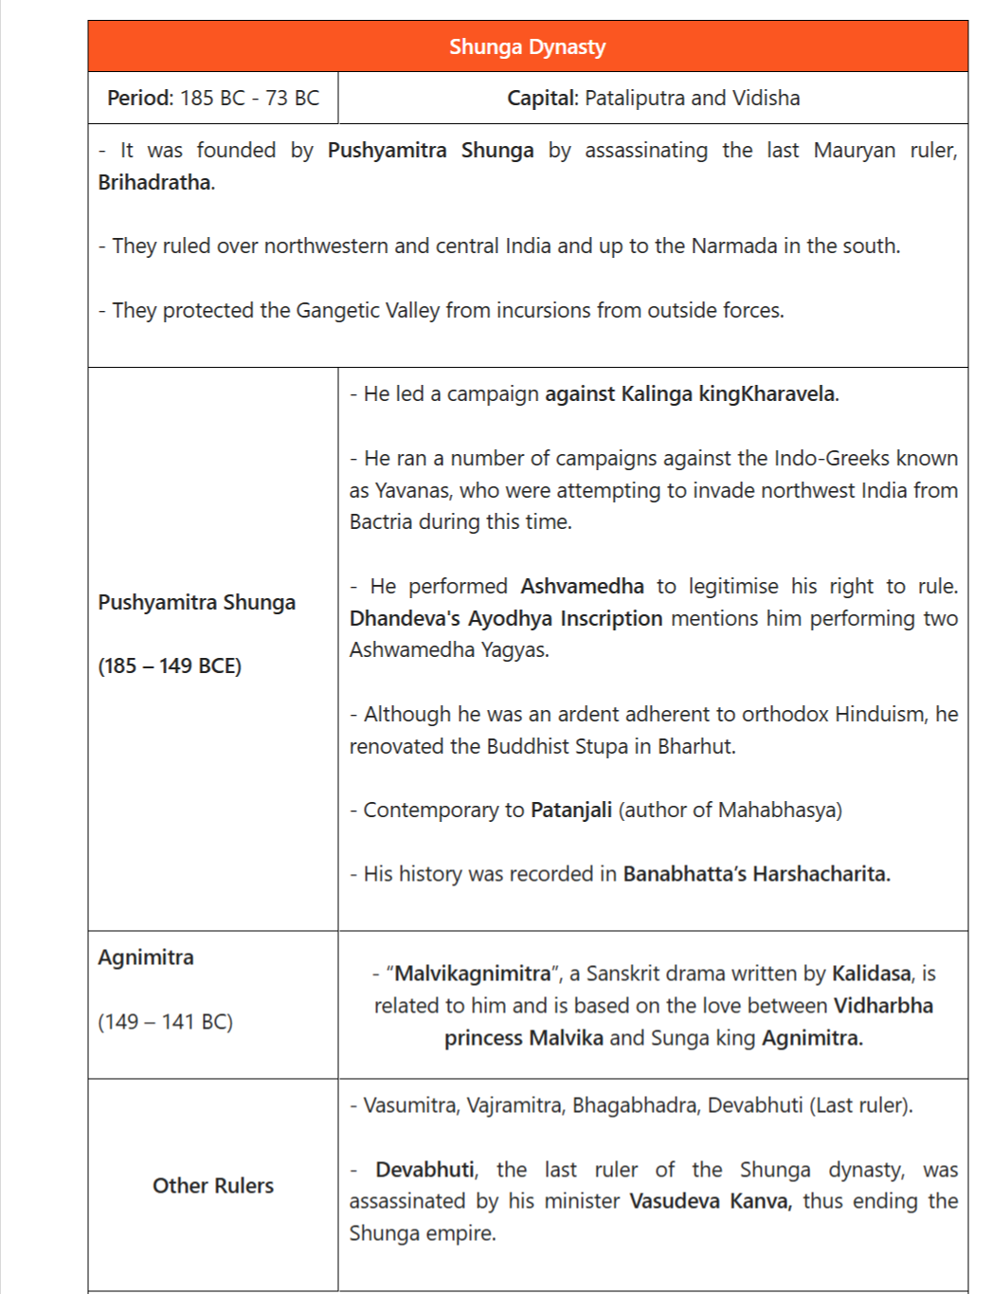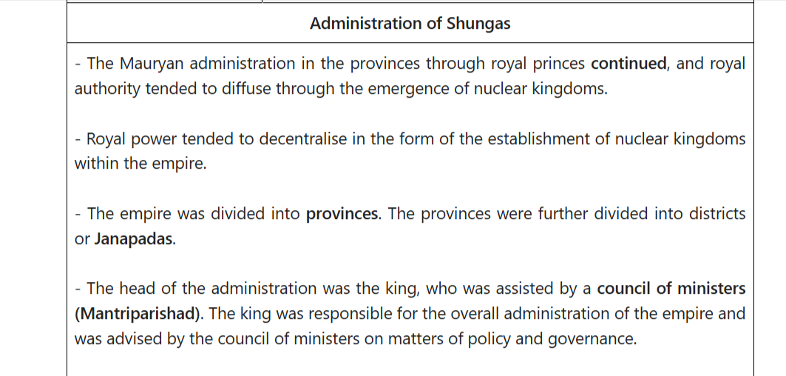

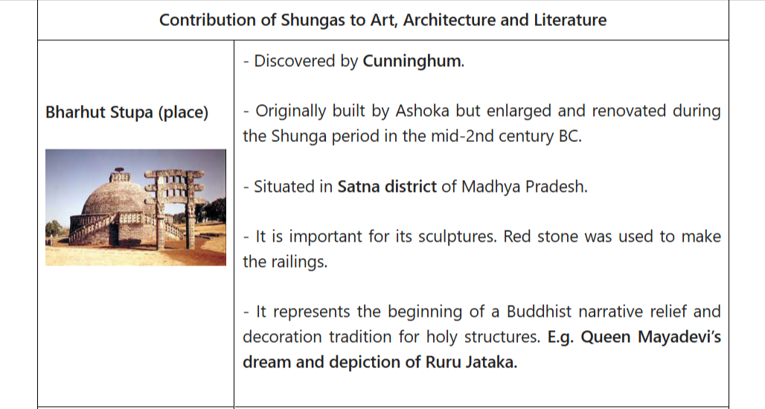
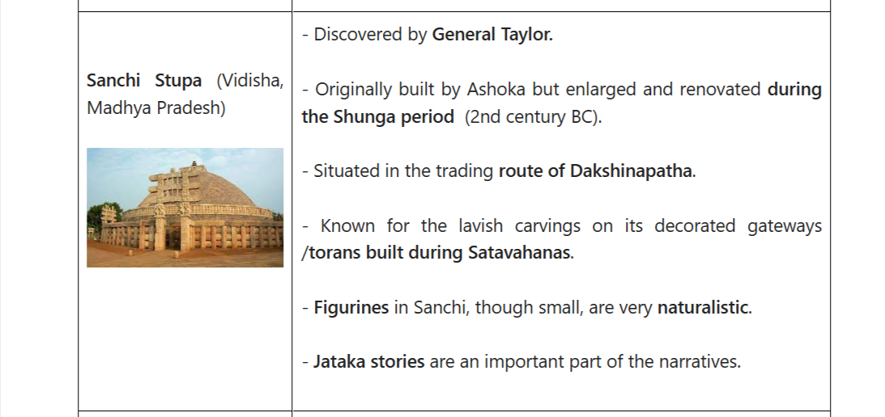

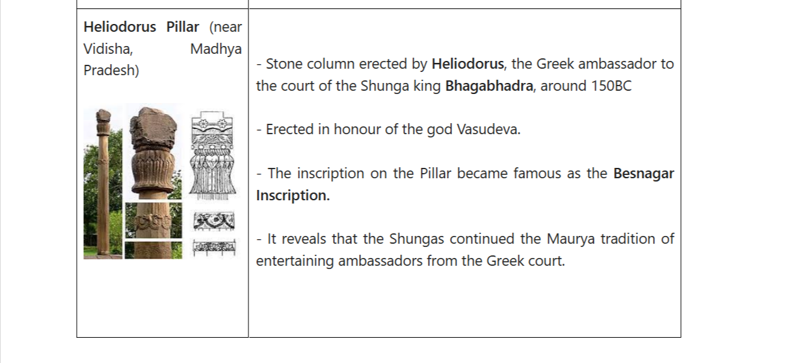

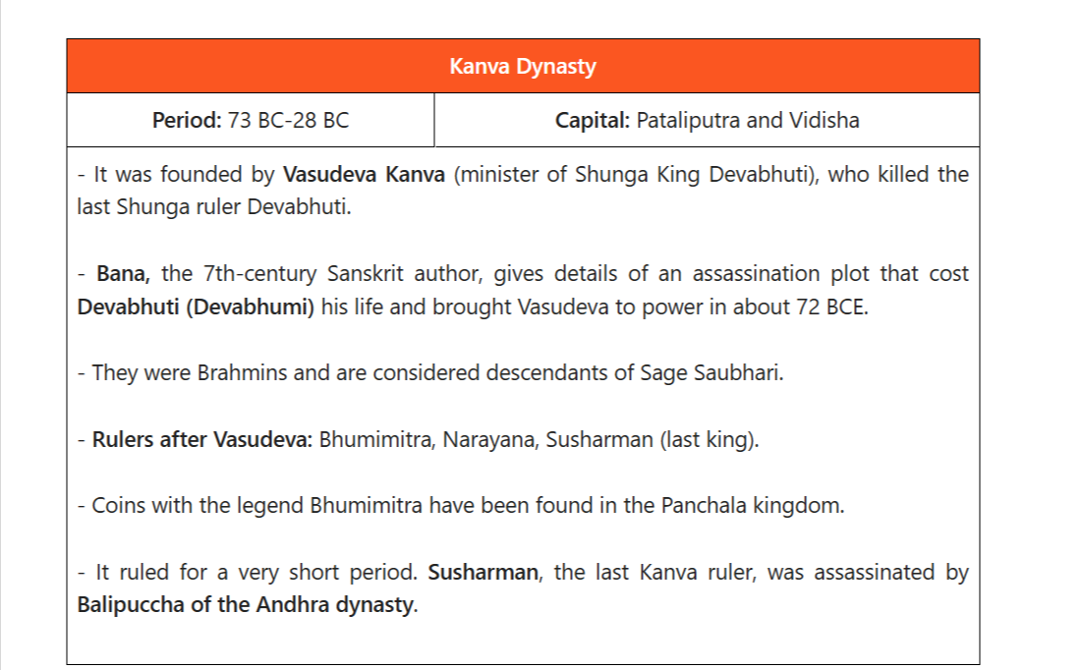

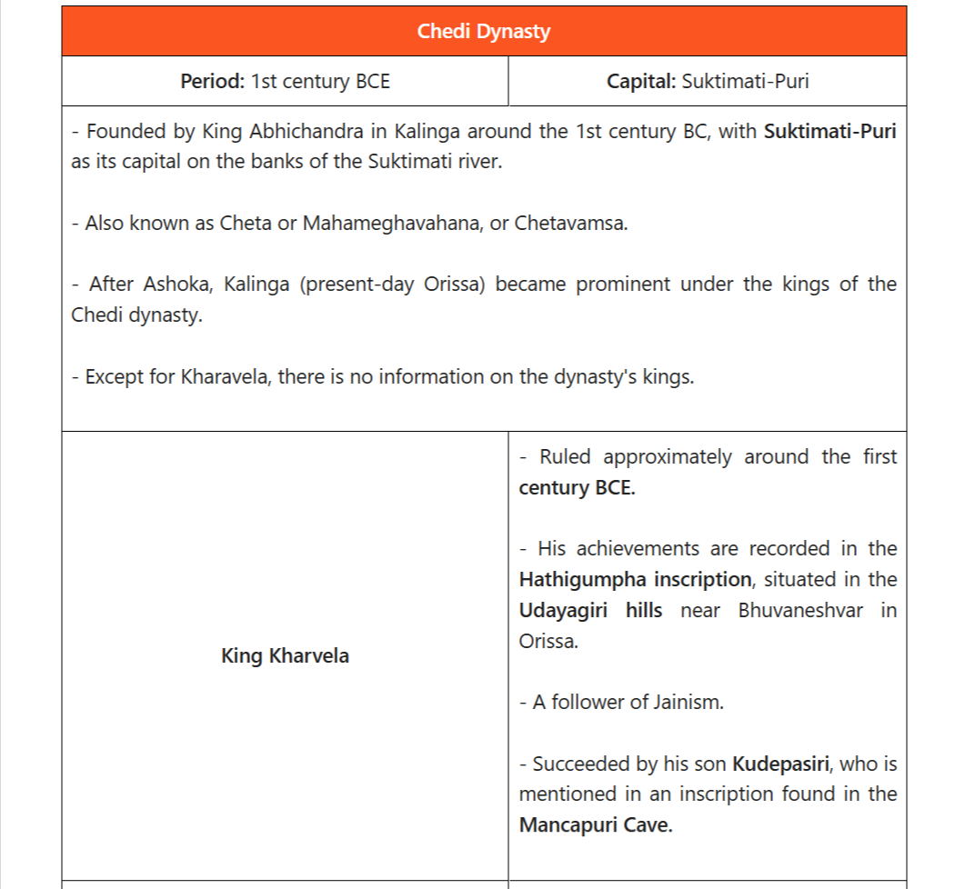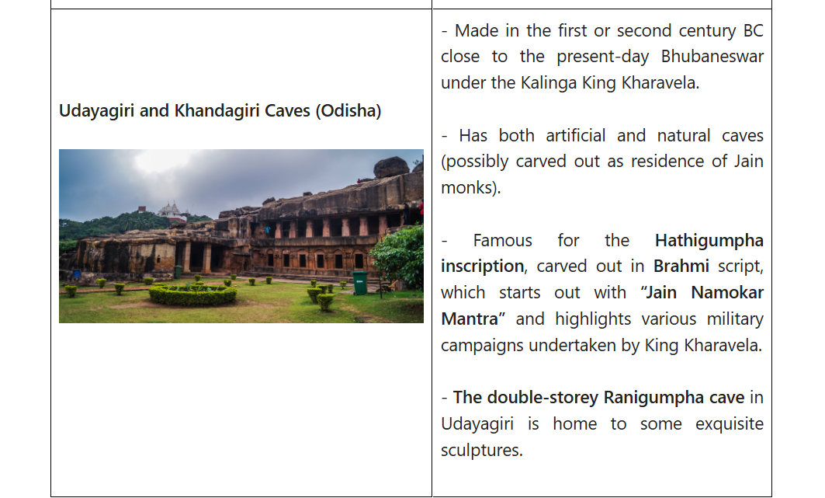

Art and Architecture of Post Mauryan Period
The art of the Post Mauryan Period started reflecting the changing socio-political scenario as well. The architecture of rock-cut caves and stupas proceeded, with each dynasty introducing its own distinctive features. Similarly, various schools of sculpture arose, and the art of sculpture reached its pinnacle in the post-Mauryan period.

Development of Stupas: Stupas are Buddhist commemorative monuments usually housing sacred relics associated with the Buddha or other saintly persons.
Three prominent stupas from this period can be found in Bharhut and Sanchi (both in Madhya Pradesh), which were originally constructed by Ashoka but later expanded, as well as Amravati and Nagarjunkonda (both in Andhra Pradesh).
Stupas became larger and more decorative in the Post Mauryan period. Stone was increasingly used in place of wood and brick.
The Shunga dynasty introduced the idea of torans as beautifully decorated gateways to the stupas.
Early Temples Architecture:
During this time, Brahmanical temples and images of gods began to be built.
Myths mentioned in the Puranas were incorporated into the narrative representation of Brahmanical religion.
Temples were decorated with the images of gods.Each temple had an image of a Chief Deity. These temples are basic structures that include a hall, a veranda, and a shrine in the back.
Important temple sites of this period: Deogarh in Uttar Pradesh, Eran, Nachna-Kuthara and Udayagiri near Vidisha in Madhya Pradesh.
There were three types of temple shrines: Sandhara type (without pradikshinapatha), Nirandhara type (with pradakshina patha) and Sarvatobhadra (accessible from all sides).... Read more at: https://vajiramandravi.com/upsc-exam/post-mauryan-period/

Religion and Society of Post-Mauryan Period
Religion and society during the post-Mauryan period witnessed the following changes.

Rise of Brahmanism: People in the post-Mauryan period practised Vedic religion, Buddhism, and Jainism. However, Brahmanism experienced a resurgence under Shunga's rule. There was an increase in rituals such as Ashwamedha and Rajasuya.
Stories of Pushyamitra's brutality and hostility against Buddhism are described in the Divyavadana.
Varna system: During the post-Mauryan period, the four-fold varna system was also revived. Thus, the social structure became rigid as the fourfold varna system was strengthened. The dominance of priests and the ruling class was strengthened, while the conditions of Shudras remained unchanged.
Position of women: Women's position in society was generally limited to domestic roles, and they were expected to follow strict codes of conduct as mentioned in the Manusmriti.
Cultural expanse: It was the period of the emergence of various mixed castes and the integration of foreigners into Indian society.
Don't miss Vajiram & Ravi updates:

Add Vajiram & Ravi as a preferred source on Google

Add
Language and Literature of the Post-Mauryan Period
The Post-Mauryan period was significant for the development of Sanskrit for religious, philosophical, and literary works.

Sanskrit became more popular during this period and was used to write Buddhist texts also.
Patanjali: His important works include: Yoga Sutras (a collection of Sanskrit sutras (aphorisms) on the theory and practice of yoga), Mahabhasya (an ancient treatise on Sanskrit grammar and linguistics) and Patanjali Tantra (medical text).
The Sanskrit language was written using the variant version of Brahmi script. It is believed that the writing serves as a link between the Kalinga Brahmi script and the Maurya script.
Trade and Commerce in Post Mauryan Period
The Post Mauryan period witnessed the flourishment of commerce and crafts in ancient India and the growth of internal and external trade and commerce.

Craft and commerce:Jyestha was the head of the guild of artisans. Mathura was famous for the production of shataka, a unique kind of cloth.
Merchant class: During this period, trade flourished and resulted in the rise of many types of merchant guilds.
Shreshti led the merchant guild (shreni), while Sarthavaha led the sartha (mobile or caravan trading corporation). Vanijgramo was the head of the corporation of merchants.
Trade routes:
Uttarapatha was the internal trade land route connecting northern and eastern parts of India with the northwestern areas.
Dakshinapatha was the trade land route connecting peninsular India with the western and northern parts of India.
Discovery of monsoon: Discovery of monsoon led to the development of external trade.
Export of spices to the Romans and import of gold and silver from Romans was common.
Around the same time, 200 BCE, there were invasions from Central Asia and western China. Among these were the Indo-Greeks, Scythians or Shakas, Parthiansor Pahlavas, and Kushanas. These invasions not only altered the political structure of northwestern India but also contributed to the transmission and transformation of cultural elements from both India and the Central Asian region.... Read more at: https://vajiramandravi.com/upsc-exam/post-mauryan-period/

FAQs on Post Mauryan Period
Q1. What is the Post Mauryan period?-

Ans. India's Post-Mauryan period was a historical period that came after the collapse of the Mauryan Empire. It started around 200 BCE and lasted until the rise of the Gupta Empire in the fourth century CE.

Q2. What was the Post-Mauryan period known for?-

Ans. It is known for cultural interactions between India and foreign rulers, the spread of Mahayana Buddhism, and the development of three schools of art and sculptures: Gandhara, Mathura and Amravati.

Q3. Who founded the Shunga dynasty, and what were their capital cities?-

Ans. The Shunga dynasty was founded by Pusyamitra Shunga. The capital cities of the Shungas were Pataliputra and Vidisha.

Q4. Who was the famous scholar in the court of Pushyamitra Sunga?-

Ans. Patanjali was a scholar of the Post-Mauryan period. His important works include the Yoga Sutras, Mahabhasya, and Patanjali Tantra. He played a key role in preserving and advancing knowledge.

Q5. What is the significance of the Hathigumpha inscription, and who is associated with it?-

Ans. The Hathigumpha inscription, located in the Udayagiri hills near Bhuvaneshvar, highlights the achievements of King Kharavel. It provides valuable information about his reign and campaign.... Read more at: https://vajiramandravi.com/upsc-exam/post-mauryan-period/

NCERT notes on important topics for the IAS aspirants. These notes will also be useful for other competitive exams like banking PO, SSC, state civil services exams and so on. This article talks about Post-Mauryan India – Sunga Dynasty.
After the death of Ashoka, the Mauryan Empire steadily disintegrated as his successors were not able to keep the vast empire from fracturing away. Independent kingdoms arose out of the provinces. Foreign invasions were occurring in the northwest. Kalinga declared its independence. In the South, the Satavahanas rose to power and in the Gangetic plains, Sunga or Shunga dynasty replaced the Mauryas.
Kickstart your UPSC 2022 preparation today!
Sunga Dynasty (UPSC Notes):-
To help ease the path of your IAS preparation, check out the Free NCERT Fundamentals Course– a comprehensive study program to help you cover the NCERTs effectively. Watch the video below to learn more:

Pushyamitra Sunga
- Pushyamitra Sunga was Brahmin army chief of Brihadratha, the last king of the Mauryas.
- During a military parade, he killed Brihadratha and established himself on the throne in 185 or 186 BC.
- According to some historians, this was an internal revolt against the last Mauryan king. Some say it was a Brahminical reaction to the Mauryan overwhelming patronage of Buddhism.
- Pushyamitra Sunga’s capital was at Pataliputra.
- He successfully countered attacks from two Greek kings namely, Menander and Demetrius.
- He also thwarted an attack from the Kalinga king Kharavela.
- He conquered Vidarbha.
- He followed Brahminism. Some accounts portray him as a persecutor of Buddhists and a destroyer of stupas but there has been no authoritative evidence to this claim.
- During his reign, the Stupas at Sanchi and Barhut were renovated. He built the sculptured stone gateway at Sanchi.
- He performed Vedic sacrifices such as Ashvamedha, Rajasuya and Vajapeya.
- Pushyamitra Sunga patronised the Sanskrit grammarian Patanjali.
- According to the Puranas, his reign lasted for 36 years. He died in 151 BC.
Agnimitra
- Was Pushyamitra’s son who succeeded him to the throne.
- His reign lasted from about 149 BC to 141 BC.
- By this time, Vidarbha broke away from the empire.
- Agnimitra is the hero of Kalidasa’s poem, Malavikagnimitram.
- His son Vasumitra succeeded him as king.
Last of the Sunga kings
- Vasumitra’s successors are not clearly known. Different names crop up in several accounts such as Andhraka, Pulindaka, Vajramitra and Ghosha.
- The last Sunga king was Devabhuti. He was preceded by Bhagabhadra.
- Devabhuti was killed by his own minister, Vasudeva Kanva in around 73 BC. This established the Kanva dynasty at Magadha from 73 to 28 BC.
Effects of Sunga rule
- Hinduism was revived under the Sungas.
- The caste system was also revived with the rise of the Brahmanas.
- Another important development during the Sunga reign was the emergence of various mixed castes and the integration of foreigners into Indian society.
- The language of Sanskrit gained more prominence during this time. Even some Buddhist works of this time were composed in Sanskrit.
- The Sungas patronised art and architecture. There was an increase in the usage of human figures and symbols in art during this period.
Sunga Dynasty (UPSC Notes):-
Frequently Asked Questions about Sunga Dynasty
Q1
Who was the founder of the Sunga dynasty?
Sunga dynasty, was founded by Pushyamitra about 185 bc .It replaced the Mauryan dynasty.
Q2
What is the Sunga Dynasty known for?
The dynasty is noted for its numerous wars with both foreign and indigenous powers. They fought the Kalinga, the Satavahana dynasty, the Indo-Greek Kingdom and possibly the Panchalas and Mitras of Mathura.

After the fall of the Mauryan Empire, many other smaller states emerged in India, some of which are the Sungas, the Kanvas, the Satavahanas, etc. It is an important period in the ancient history of India and in hence, important for the UPSC exam. In this article, you can read all about the crafts, trade and towns in Post-Mauryan India.
To know everything about the Mauryan Empire, click on the linked article.
Post-Mauryan Age – Crafts, Trade & Towns:-
Post-Mauryan Age – Crafts
The age of the Sakas, the Satavahanas and the Kushanas (200 BCE – 200 CE) and the first Tamil states was the most flourishing period in the history of commerce and crafts in ancient India.
- The Digha-Nikaya, which belongs to the pre-Mauryan times, mentions almost 24 occupations whereas the Mahavastu, a text belonging to this period, catalogues 3 dozen different types of workers living in Rajgir town.
- The Milinda Panho (the questions of Milinda) mentions about 75 occupations, out of which 60 are connected with various kinds of crafts.
- Craftsmen are largely associated with towns in literary texts, but some excavations show that they lived in villages as well.
- The field of mining and metallurgy made great advancements and specializations, as many as eight crafts were associated with the working of gold, lead, silver, tin, brass, copper, iron, jewels and precious stones.
  - The technological progress in iron manufacturing is clear from the excavations of specialized iron artefacts from the Nalgonda and Karimnagar districts of Telangana.
  - Iron and steel products from India like cutlery were exported to Abyssinian ports and were regarded higly in western Asia.
- The inscriptions of this period mention goldsmith, weavers, dyers, jewellers, workers in metal and ivory, sculptors, smiths, fishermen and perfumers, suggesting that these crafts were thriving.
  - Mathura and Vanga (Eastern Bengal) were famous for varieties of silk and cotton textiles, with the former being known for a special kind of cloth known as Shataka.
  - The excavations of dyeing vat at Uraiyur (Tamil Nadu) and at Arikamedu suggest that dyeing was a flourishing art in these areas in this age.
  - Ujjain was an important bead making centre. The ivory products, glass objects and beads of precious and semi-precious stones were articles of luxury.
  - Coin minting was a major craft and coins were made of gold, copper, silver, lead, potin and bronze. The craftsmen even made fake coins.
- Gorgeous pieces of terracotta have been found in almost all Satavahana and Kushana sites, especially Yelleshwaram in the Nalgonda district. It is generally accepted that terracotta was chiefly utilised by people of the upper classes in towns. There are innumerable inscriptions that talk about donations given by prosperous artisans to the monasteries.
Merchant Guilds
- The merchants communities were organised in groups called “shreni” or guild under the head – Shreshthi.
- Mobile or caravan trading corporations of inter-regional traders formed another type of mercantile group called “sartha” with its leader called “sarthavaha”.
- Almost all craft occupations were also organised into guilds, under a head called “jetthaka/pamukkha”.
- The guilds were associations of merchants & craftsmen, in the same profession or dealing in the same commodity.
- Each guild had its heads and followed its own rules with respect to quality and prices in order to regulate their business on the basis of mutual goodwill.
- These guilds also served as banks and kept public deposits from the public on fixed interest rates.
- On the basis of information from different texts, it can be inferred that artisans were organised into at least 24 guilds.
- Most of the artisans were limited to the Mathura region and western Deccan (areas that were on the trade routes that led to the western coastal ports).
- The Yajnavalkya Smriti talks about the qualifications and powers of the head of the guilds. According to the text, the guilds also probably had a judicial role.
- According to Buddhist texts, the heads of the guilds had a good rapport with the king and used to accompany the king as part of the official entourage and sometimes were even appointed as Mahamattas.
- In Nigrodha Jataka, it is mentioned that certain officials called “bhandagarika” were designated to maintain a record of the conventions and transactions of the guilds.
- Some guilds even issued coins and seals which reflect the importance of guilds of this period.
  - Some seals with the captions nigama, nigamasya have been found at the site of Rajghat, seals with the legend of Gavayaka (signifying milkmen’s guild), Bhita (seals with the legend of Shulaphalayikanam, signifying guild of arrowhead makers) and Ahichchhatra (seals with the legend of Kumhakara, signifying pottery makers’ guild).
Post-Mauryan Age – Trade
One of the most salient aspects of the post-Mauryan period was the growth of internal and external trade and commerce.
- There were two major internal land routes in ancient India:
  - Uttarapatha: Connected eastern and northern parts of India with the north-western areas, and
  - Dakshinapatha: Connected peninsular India with northern and western parts of India.
- The Uttarapatha was in more frequent use.
- From Taxila, it passed via Punjab up to the western coast of the Yamuna, following the western coast of Yamuna it went southwards to Mathura.
- From Mathura, it passed on to Ujjain in Malwa and from Ujjain to Broach on the western coast.
- The Broach port seems to be the most important and flourishing amongst the other ports, as the goods produced in the Shaka, the Kushana and the Satavahana kingdoms were brought to it for export.
- There was flourishing trade between India and Rome.
- In addition to the articles directly supplied by India to the Roman empire, certain items were brought from China and Central Asia to India and then sent to the eastern part of the Roman empire. For instance, silk was directly sent from China to the Roman empire through the famous silk route passing through northern Afghanistan and Iran. After the annexation of Iran by Parthians, silk was diverted to the western Indian ports through north-western part of the subcontinent and sometimes it was transported via the east coast to the west coast of India. Thus, a lot of transit trade was there in silk between India and Rome.
Post-Mauryan Age – Urban Settlements
Towns prospered in the Kushana and the Satavahana empires because of the growing trade with the Roman empire.
- The country traded with the eastern part of the Roman empire as well as with Central Asia.
- Towns in Punjab and western Uttar Pradesh thrived because the centre of the Kushana power lay in northwestern India. Most Kushana towns in India lay exactly on the northwestern or Uttarapatha route passing from Mathura to Taxila.
- The excavations reveal that the urbanisation was at peak in the Kushana phase which is also applicable to the towns in the Shaka kingdom, of Malwa and western India.
- The most important town was Ujjain because of it being the nodal point of two routes – one from Kaushambi and the other from Mathura.
- The end of the Kushana empire in the 3rd century CE gave a huge blow to the towns.
- Also, with the ban on trade with India imposed by the Roman empire from the 3rd century CE, towns could not support the artisans and merchants of the Deccan region.
- Archaeological evidence also suggests a decline in the urban settlements after the Satavahana phase.
Related Links
UPSC Mains Exam | Government Exams
NCERT Notes | NCERT notes on Ancient History for UPSC
Mauryan Art And Architecture | Persian and Greek Invasions of Ancient India
Comments
Leave a Comment

Subject: History
Category: Art and Culture
Topic: Post-Mauryan Trends in Indian Art and Architecture – Part I
NCERT notes on important topics for the UPSC civil services exam preparation. These notes will also be useful for other competitive exams like banking PO, SSC, state civil services exams and so on.
Introduction
- After the decline of the Mauryan Empire in the second century BC, various rulers controlled the regions which were once under the Mauryas, like the Shungas, Kanvas, Kushanas and Guptas in the north and central India; and the Satavahanas, Abhiras, Ikshvakus and Vakatakas in the south and western India.
- This period also saw the emergence of Brahmanical sects like the Shaivas and the Vaishnavas.
- Chief examples of fine sculpture are found at Bharhut and Vidisha (Madhya Pradesh); Mathura (Uttar Pradesh); Bodhgaya (Bihar); Jaggayyapeta (Andhra Pradesh); Bhaja and Pavani (Maharashtra); and Khandagiri and Udaigiri (Odisha).
Check out the famous Arts of the Mauryan Period on the linked page.
Post-Mauryan Trends in Indian Art and Architecture (UPSC Notes):-
Aspirants can check the following links to align their preparation for UPSC 2021 examination:
- Previous Year Topic Wise UPSC Prelims Questions PDF’
- 100 Difference between Articles
- UPSC Previous Year Question Papers
- Stay updated with Current Affairs
- Download UPSC Notes PDF (Free)
- Take the IAS Mock Tests
- Static GK
- Daily Current Affairs
- Comprehensive News Analysis
- Analysis of Press Information Bureau Release
- Download NCERT Notes for UPSC PDF (Free)
Post Mauryan Art and Architecture
Bharhut
- Sculptures are tall like the Yakshas and Yakshinis of the Mauryan era.
- The illusion of three-dimensionality is present.
- Narratives or stories are represented pictorially.
- Space is utilised to the maximum extent.
- Initially, the carvings were shown with flat images, i.e., projection of hands and feet were not possible, but later on, they emerged with deep carvings and a much-naturalised representation of human and animal forms.
- One important sculpture at Bharhut: Queen Mayadevi (the Buddha’s mother) dreaming of an elephant descending towards her womb.
- Jataka tales are also seen.
- A common characteristic of all the male images after the first and second centuries is the knotted headgear.
Sanchi
You can read about Sanchi Stupa here.
Mathura, Sarnath and Gandhara Schools
- Gandhara (in modern Pakistan), Mathura and Sarnath emerged as important art production centres from the first century AD onwards.
- Buddha gets a human form in Mathura and Gandhara. Previously he was represented via symbols.
- Gandhara art form influenced Indo-Greek elements such as Bactria and Parthia traditions besides the local Gandhara tradition.
  - The Buddha images here have Hellenistic features.
  - The Buddha here is more muscular.
  - The sculptures are heavily polished with rich carvings.
  - The hair is curly and the lobes of the ears are elongated.
  - The garments are generally flowing in nature.
  - The sculptures were initially made of stone and later on stucco was also used.
- The Mathura art tradition became so strong that it spread to other parts of northern India.
  - Best example: Stupa sculpture at Sanghol, Punjab.
  - The Buddha images in the Mathura school are modelled on the earlier Yaksha images.
  - Mathura art form also has some images of the Shaiva and Vaishnava faiths but images of the Buddha are numerous.
  - There is less symbolism here as compared to the Gandhara School.
  - The sculptures are generally made of red sandstone.
  - The garments are clearly visible and they usually cover the left shoulder. Multiple folds are shown.
  - The halo around the deity is profusely decorated.
  - In the 2nd century, the images get fleshier and their rotundity increase.
  - In the 3rd century, the fleshiness is reduced. Movement is shown by increasing the distance between the legs and bending of the body. There is more softness in the surface.
  - But in the late 4th century, this trend is reversed and the flesh becomes tightened.
  - In the 5th and 6th centuries, the drapery is integrated into the mass.
- Sarnath and Kosambi also emerged as important centres of art besides the traditional centre Mathura.
  - The Buddha images in Sarnath have transparent drapery covering both shoulders.
  - The halo around the Buddha is hardly decorated.
Candidates preparing for upcoming UPSC examinations can check the following relevant links to prepare comprehensively –
Mauryan Empire (322 BCE -185 BCE) | Mauryan Empire – Rulers, Achievements, Timelines | Mauryan Administration
Post-Mauryan India – The Satavahanas | The decline of the Mauryan Empire | Post-Mauryan India – Sunga Dynasty
Emperor Ashoka | Ashoka’s Edicts | Post-Mauryan India – Sunga Dynasty
Early temples
- Apart from Stupas, Brahmanical temples also started getting built.
- Temples were decorated with the images of gods and also representations of the Purana myths.
- Every temple had a principle image of a god.
- There were 3 kinds of shrines of the temples:
  - Sandhara type: without pradakshinapatha (circumambulatory path)
  - Nirandhara type: with pradakshinapatha
  - Sarvatobhadra: which can be accessed from all sides
- Important temple sites from this period: Deogarh (UP); Eran, Udaygiri, Nachna-Kuthara (near Vidisha in MP). These are simple structures with a veranda, a hall and the shrine at the back.
Buddhist Monuments of South India
- The Vengi region in Andhra Pradesh has many stupas, in Jaggayyapeta, Amaravati, Nagarjunakonda, Bhattiprolu, Goli, etc.
- Amaravati School of Art
  - Developed during the Satavahana period.
  - This is fully indigenous in nature and had profound influence on art in Sri Lanka and south-east Asia since products from here were taken to those places.
  - Had many sculptures and has a Mahachaitya. The sculptures are preserved in Chennai Museum, National Museum at Delhi, Amaravati Site Museum and the British Museum at London.
  - Amaravati Stupa has a pradakshinapatha and a vedica (fence) with many sculptures on it. The torana (gateway) has disappeared.
  - Unique feature of this stupa: the dome is covered with relief stupa sculptural slabs.
  - Events from Buddha’s life and Jataka tales are depicted.
  - It was first built in the first century AD and later centuries developed or enhanced.
  - Initial phase does not show Buddha images but they are seen from the later stages (like the stupa at Sanchi).
  - The sculptures have intense emotions. The figures are slender and show a lot of movement. The bodies are shown with 3 bents (tribhanga).
  - The structures are more complex than at Sanchi and are more animated.
  - There is a lot of attention paid to the forms’ clarity.
- The sculptures of Goli and Nagarjunakonda in the 3rd century are reduced in animation but still very three-dimensional.
- Independent Buddha images at: Amaravati, Nagarjunakonda and Guntapalle. Guntappale: Rock-cut cave site near Elluru.
- Other rock-cut stupas found at: Anakapalle (near Vishakhapatnam); and Sannati (largest in Karnataka).
- Apart from Buddha images, images of Boddhisattvas like Avalokiteshvara, Vajrapani, Padmapani, Amitabha and Maitreya Buddha are also seen.
This chapter is continued in the link below:
NCERT Notes: Post-Mauryan Trends in Indian Art and Architecture – Part II
Post-Mauryan Trends in Indian Art and Architecture (UPSC Notes):-
Aspirants can visit the UPSC Syllabus page to familiarise themselves with the topics generally asked in the exam. For further assistance visit the following links –
UPSC Books | UPSC Monthly Current Affairs Magazine | Current Affairs Quiz
UPSC Mains GS 1 Strategy & Syllabus | Documents Required for UPSC Exam | NCERT Books
Civil Services Syllabus | Current Affairs Question | IAS Salary
UPSC Prelims Ancient History Questions & Answers [2013-2020] | UPSC Prelims Modern History Questions & Answers PDF | UPSC Prelims Medieval History Questions & Answers [2013-2020]
Previous Years History Questions in UPSC Mains General Studies Paper 1 | History Books For IAS Exam | Previous Years Art and Culture Questions in UPSC Mains General Studies Paper 1
Comments

